**[In Part 30 of this video series](http://csharp-video-tutorials.blogspot.com/2012/09/scalar-user-defined-functions-in-sql.html)** we have seen how to create and call '**scalar user defined functions**'. In this part of the video series, we will learn about '**Inline Table Valued Functions**'.  
  
From Part 30, We learnt that, a scalar function, returns a **single**value. on the other hand, an Inline Table Valued function, return a **table**.   
  
**Syntax for creating an inline table valued function**  
CREATE FUNCTION Function_Name(@Param1 DataType, @Param2 DataType..., @ParamN DataType)  
RETURNS TABLE  
AS  
RETURN (Select_Statement)   
  
   
  
   
  
   
  
**Consider this Employees table** shown below, which we will be using for our example.   
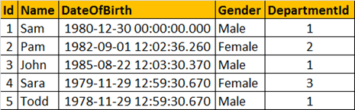  
  
  
**Create a function that returns EMPLOYEES by GENDER.**  
CREATE FUNCTION fn_EmployeesByGender(@Gender nvarchar(10))  
RETURNS TABLE  
AS  
RETURN (Select Id, Name, DateOfBirth, Gender, DepartmentId  
     from tblEmployees  
     where Gender = @Gender)  
  
**If you look at the way we implemented this function**, it is very similar to SCALAR function, with the following differences  
1. We specify **TABLE**as the return type, instead of any **scalar** data type  
2. The **function body** is not enclosed between **BEGIN and END** block. Inline table valued function body, cannot have BEGIN and END block.  
3. The **structure of the table** that gets returned, is determined by the SELECT statement with in the function.  
  
**Calling the user defined function**  
Select * from fn_EmployeesByGender('Male')   
  
**Output:**  
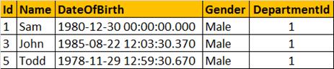   
  
As the inline user defined function, is returning a table, issue the select statement against the function, as if you are selecting the data from a TABLE.  
  
**Where can we use Inline Table Valued functions**  
1. Inline Table Valued functions can be used to achieve the functionality of parameterized views. We will talk about views, in a later session.  
2. The table returned by the table valued function, can also be used in joins with other tables.  
  
**Consider the Departments Table**  
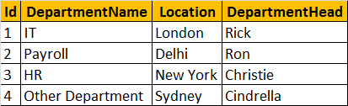  
  
**Joining the Employees returned by the function, with the Departments table**  
Select Name, Gender, DepartmentName   
from fn_EmployeesByGender('Male') E  
Join tblDepartment D on D.Id = E.DepartmentId  
  
**Executing the above query should produce the following output**  
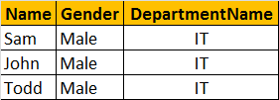   
  
**New to joins in sql server. Please check the videos below**  
[Part 12 - Basic Joins](http://csharp-video-tutorials.blogspot.com/2012/08/joins-in-sql-server-part-12.html)  
[Part 13 - Advanced Joins](http://csharp-video-tutorials.blogspot.com/2012/08/advanced-joins-part-13.html)  
[Part 14 - Self Joins](http://csharp-video-tutorials.blogspot.com/2012/08/self-join-in-sql-server-part-14.html)